Ahmed Ragab Section 1

* **Question NO. 1**

In the Hypothetical Machine the contents of memory were as shown. And PC contents is 300. Show the contents of memory and PC, AC, IR after execute three instructions (three fetch cycle and there execute cycle)

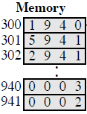In the Hypothetical Machine the contents of memory were as shown. And PC contents is 300. Show the contents of memory and PC, AC, IR after execute three instructions (three fetch cycle and there execute cycle)

**Answer:**

|  |  |  |
| --- | --- | --- |
| Fetch Cycle |  | Execute Cycle |
| |  |  | | --- | --- | | **PC** | **300** | | **AC** |  | | **IR** | **1940** | |  | |  |  | | --- | --- | | **PC** | **300** | | **AC** | **0003** | | **IR** | **1940** | |
| |  |  | | --- | --- | | **PC** | **301** | | **AC** | **0003** | | **IR** | **5941** | |  | |  |  | | --- | --- | | **PC** | **301** | | **AC** | **0005** | | **IR** | **5941** | |
| |  |  | | --- | --- | | **PC** | **302** | | **AC** | **0005** | | **IR** | **2941** | |  | |  |  | | --- | --- | | **PC** | **302** | | **AC** | **0000** | | **IR** | **2941** | |

* **Question NO. 2**

Show the contents of PC, AC and IR and memory after the execution of each instruction of the following program on the Hypothetical Machine:

300 LOAD 550

301 ADD 551

302 STORE 600

**Answer:**

|  |  |  |
| --- | --- | --- |
| Fetch Cycle |  | Execute Cycle |
| |  |  | | --- | --- | | **PC** | **300** | | **AC** |  | | **IR** | **1550** | |  | |  |  | | --- | --- | | **PC** | **300** | | **AC** | **0003** | | **IR** | **1550** | |
| |  |  | | --- | --- | | **PC** | **301** | | **AC** | **0003** | | **IR** | **5551** | |  | |  |  | | --- | --- | | **PC** | **301** | | **AC** | **0007** | | **IR** | **5551** | |
| |  |  | | --- | --- | | **PC** | **302** | | **AC** | **0007** | | **IR** | **2600** | |  | |  |  | | --- | --- | | **PC** | **302** | | **AC** | **0000** | | **IR** | **2600** | |

* **Question NO. 3**

The following figure provide the main characteristics of Hypothetical Machine.

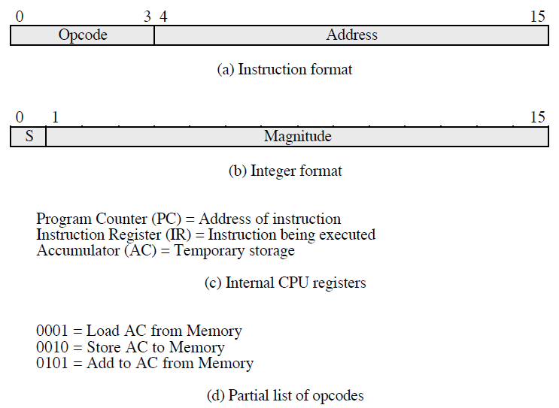

The hypothetical machine also has two I/O instructions:

0011 = load AC from I/O

0111 =store AC to I/O

In these cases, the 12-bi address identifies a particular I/O device. Show the program execution for the following program:

1. Load AC from device 5.

2. Add contents of memory location 940.

3. Store AC to device 6.

Assume that the next value retrieved from device 5 is 3 and that location 940 contains a value of 2.

**Answer:**

|  |  |
| --- | --- |
| **300** | **3005** |
| **301** | **5940** |
| **302** | **7006** |

**After finishing:**

**Device 5: 0003**

**940: 2**

**Device 6: 0005**